BHARAT SHRINIVAS HEGDE
CSE 3D
1BM25CS413-T (Diploma)

LAB PROGRAM 7A
WAP to Implement doubly link list with primitive operations
a) Create a doubly linked list.
b) Insert a new node to the left of the node.
c) Delete the node based on a specific value
d) Display the contents of the list.

Code:
#include <stdio.h>
#include <stdlib.h>

// Define the structure of a node
struct Node {
int data;
struct Node *prev;
struct Node *next;
};
struct Node *head = NULL;
// Create a doubly linked list
void create() {
int n, value;
struct Node *temp, *newNode;

printf("Enter number of nodes: ");
scanf("%d", &n);
for (int i = 0; i < n; i++) {
newNode = (struct Node *)malloc(sizeof(struct Node));
printf("Enter value: ");
scanf("%d", &value);
newNode->data = value;
newNode->prev = NULL;
newNode->next = NULL;

if (head == NULL) {
head = newNode;
} else {
temp = head;
while (temp->next != NULL)
temp = temp->next;

temp->next = newNode;
newNode->prev = temp;
}
}
}

// Insert a new node to the LEFT of a given value
void insertLeft() {
int key, value;
struct Node *temp, *newNode;

if (head == NULL) {
printf("List is empty!\n");
return;
}
printf("Enter the value before which to insert: ");
scanf("%d", &key);
printf("Enter new value: ");
scanf("%d", &value);
temp = head;
while (temp != NULL && temp->data != key)
temp = temp->next;
if (temp == NULL) {
printf("Value not found!\n");
return;
}
newNode = (struct Node *)malloc(sizeof(struct Node));
newNode->data = value;
newNode->next = temp;
newNode->prev = temp->prev;

if (temp->prev != NULL)
temp->prev->next = newNode;
else
head = newNode;

temp->prev = newNode;
}
// Delete a node by specific value
void deleteValue() {
int key;
struct Node *temp;
if (head == NULL) {
printf("List is empty!\n");
return;
}
printf("Enter value to delete: ");
scanf("%d", &key);
temp = head;
while (temp != NULL && temp->data != key)
temp = temp->next;
if (temp == NULL) {
printf("Value not found!\n");
return;
}
if (temp->prev != NULL)
temp->prev->next = temp->next;
else
head = temp->next;
if (temp->next != NULL)
temp->next->prev = temp->prev;
free(temp);
printf("Node deleted successfully.\n");
}

// Display the list
void display() {
struct Node *temp;

if (head == NULL) {
printf("List is empty!\n");
return;
}
temp = head;
printf("Doubly Linked List: ");
while (temp != NULL) {
printf("%d <-> ", temp->data);
temp = temp->next;
}
printf("NULL\n");
}

// Main function (Menu Driven)
int main() {
int choice;
while (1) {
printf("\n\n--- DOUBLY LINKED LIST MENU ---\n");
printf("1. Create List\n");
printf("2. Insert to Left of a Node\n");
printf("3. Delete Node by Value\n");
printf("4. Display List\n");
printf("5. Exit\n");
printf("Enter your choice: ");
scanf("%d", &choice);
switch (choice) {
case 1:
create();
break;
case 2:
insertLeft();
break;
case 3:
deleteValue();
break;
case 4:
display();
break;
case 5:
exit(0);
default:
printf("Invalid choice!\n");
}
}
return 0;
}

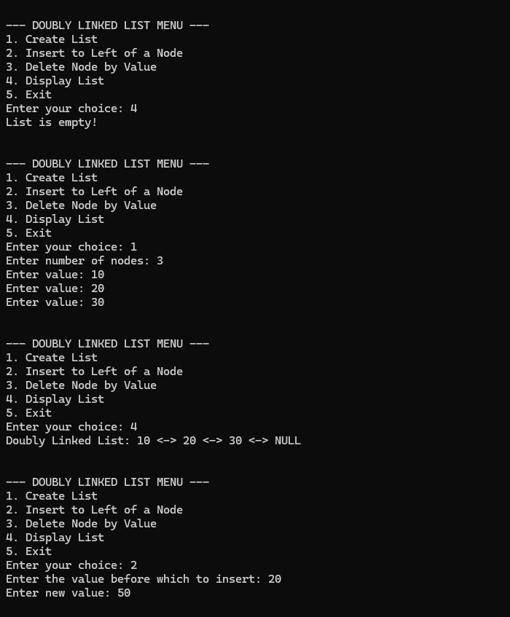
Output:

